PhET Friction Guided Worksheet

Before you begin, make sure to have “values”, “masses”, and “speed” checked.

1. a. Are balance or unbalanced forces acting on the object at this time?

b. Is the object accelerating? Why or how do you know?

Apply a force of 50N using the button.

2. Identify the forces currently acting on the object.
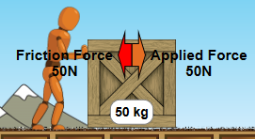

3. a. What is the net force of the object?

b. Is the object accelerating? Why or how do you know?

Apply a force of 150N using the button.

4. a. What is the net force of the object?
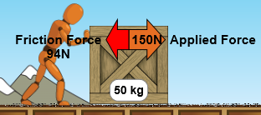
b. Are the forces balance or unbalance at this time?

c. What is the object doing at this time? Why?

5. Is the object accelerating? Why or how do you know?

Hit to reset the simulation.
Before you begin, make sure to have “values”, “masses”, and “speed” checked.

Apply a force of 150N using the button again.
When the box reaches the velocity of 20m/s, press the pause button .

6. Predict what will happen if we remove the person.

Click on the person to remove him and check if your prediction was correct.

7. What happen to the object? Why did this happen?
(Use VOCABULARY WORDS when you explain why).

Wrap Up Questions:
8. If you apply a force on an object and the object accelerates forward, explain the relationship between your force and the force of friction.

9. If you apply a force on an object and the object does not move, explain the relationship between your force and the force of friction.

10. If you increase the friction in the simulation, how would this change the amount of force needed to accelerate the object?

11. If you decrease the friction in the simulation, how would this change the amount of force needed to accelerate the object?

